WEEK 1 : COGNIZANT FSE HANDS-ON EXERCISES
Exercise 1: Implementing the Singleton Pattern
Logger.java
public class Logger
{
private static Logger instance;
private Logger() {
}
public static Logger getInstance()
{
if (instance == null)
{
instance = new Logger();
}
return instance;
}
public void log(String message)
{
System.out.println(message);
}
}
SingleTonTest.java
public class SingletonTest {

public static void main(String[] args) {

Logger logger1 = Logger.getInstance();
Logger logger2 = Logger.getInstance();

logger1.log("Logging from Instance 1");
logger2.log("Logging from Instance 2");

if (logger1 == logger2)
{
System.out.println("Only one Logger instance exists.");
} else
{
System.out.println("Multiple instances created.");
}
}
}

Output:
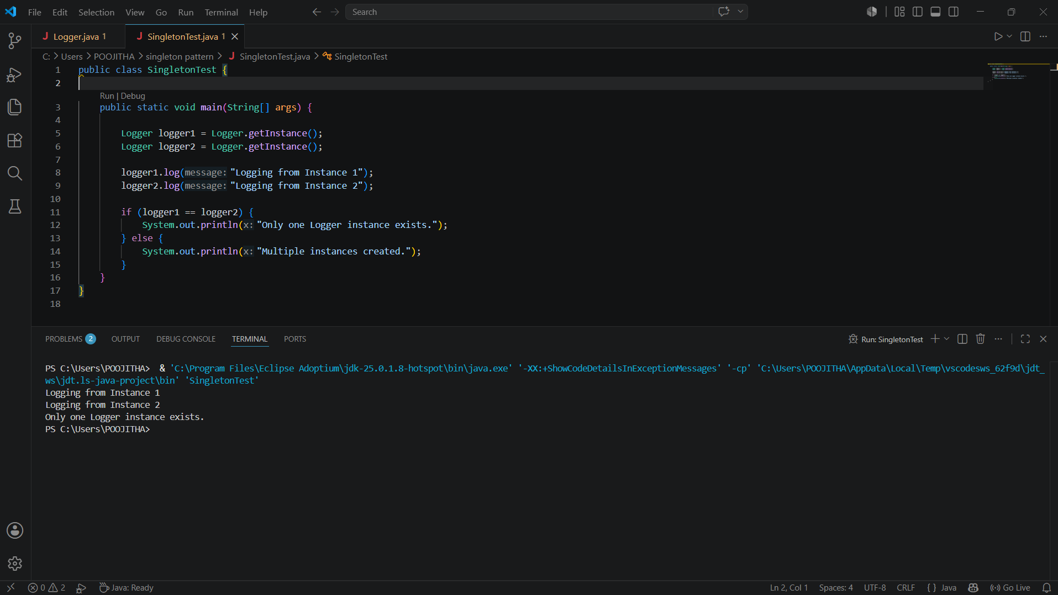

Exercise 2: Implementing the Factory Method Pattern
Document.java
public interface Document {
void open();
}

DocumentFactory.java
public abstract class DocumentFactory
{
public abstract Document createDocument();

public void create() {
Document document = createDocument();
document.open();
}
}
ExcelDocument.java
public class ExcelDocument implements Document {

@Override
public void open() {
System.out.println("Excel Document Created");
}
}
ExcelDocumentFactory.java
public class ExcelDocumentFactory extends DocumentFactory {

@Override
public Document createDocument() {
return new ExcelDocument();
}
}
FactoryMethodTest.java
public class FactoryMethodTest {

public static void main(String[] args) {

DocumentFactory word = new WordDocumentFactory();
word.create();

DocumentFactory pdf = new PdfDocumentFactory();
pdf.create();

DocumentFactory excel = new ExcelDocumentFactory();
excel.create();
}
}
PdfDocument.java
public class PdfDocument implements Document {

@Override
public void open() {
System.out.println("PDF Document Created");
}
}
PdfDocumentFctory.java
public class PdfDocumentFactory extends DocumentFactory {

@Override
public Document createDocument() {
return new PdfDocument();
}
}
WordDocument.java
public class WordDocument implements Document
{
@Override
public void open()
{
System.out.println("Word Document Created");
}
}
WordDocumentFactory.java
public class WordDocumentFactory extends DocumentFactory {

@Override
public Document createDocument()
{
return new WordDocument();
}
}

Output:

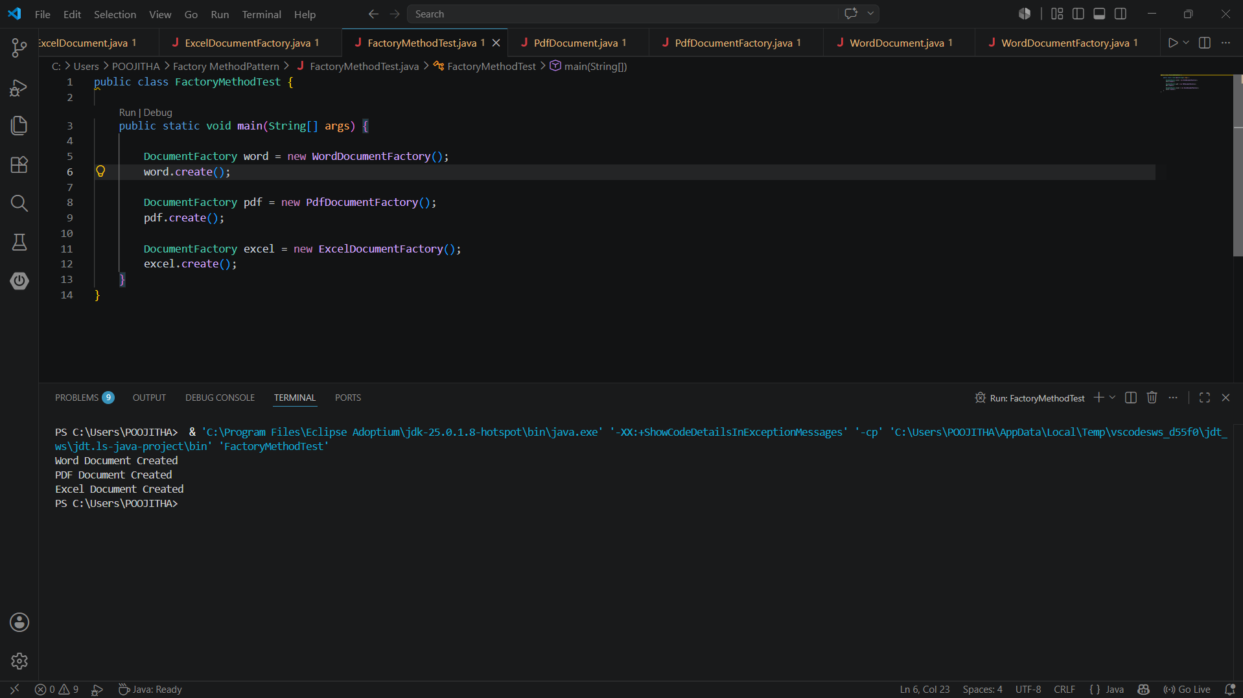

E-commerce Platform Search Function
Product.java
public class Product {

int productId;
String productName;
String category;

public Product(int productId, String productName, String category) {
this.productId = productId;
this.productName = productName;
this.category = category;
}

public void display() {
System.out.println(productId + " " + productName + " " + category);
}
}
SearchTest.java
import java.util.Arrays;
import java.util.Comparator;
public class SearchTest
// Linear Search
public static Product linearSearch(Product[] products, String name) {

for (Product product : products) {
if (product.productName.equalsIgnoreCase(name)) {
return product;
}
}
return null;
}
// Binary Search
public static Product binarySearch(Product[] products, String name) {
int left = 0;
int right = products.length - 1;
while (left <= right) {
int mid = (left + right) / 2;
int compare = products[mid].productName.compareToIgnoreCase(name);

if (compare == 0) {
return products[mid];
}
if (compare < 0) {
left = mid + 1;
} else {
right = mid - 1;
}
}
return null;
}
public static void main(String[] args) {
Product[] products =
new Product(101, "Laptop", "Electronics"),
new Product(102, "Mobile", "Electronics"),
new Product(103, "Shoes", "Fashion"),
new Product(104, "Watch", "Accessories"),
new Product(105, "Book", "Education")
};
System.out.println("Linear Search");
Product result1 = linearSearch(products, "Shoes");
if (result1 != null) {
result1.display();
} else {
System.out.println("Product Not Found");
}

Arrays.sort(products, Comparator.comparing(p -> p.productName));

System.out.println();

System.out.println("Binary Search");

Product result2 = binarySearch(products, "Shoes");

if (result2 != null) {
result2.display();
} else {
System.out.println("Product Not Found");
}

System.out.println();

System.out.println("Time Complexity Analysis");

System.out.println("Linear Search : Best O(1), Average O(n), Worst O(n)");
System.out.println("Binary Search : Best O(1), Average O(log n), Worst O(log n)");

System.out.println();

System.out.println("Binary Search is faster for large sorted datasets.");
System.out.println("Linear Search is suitable for small or unsorted datasets.");
}
}

Output:
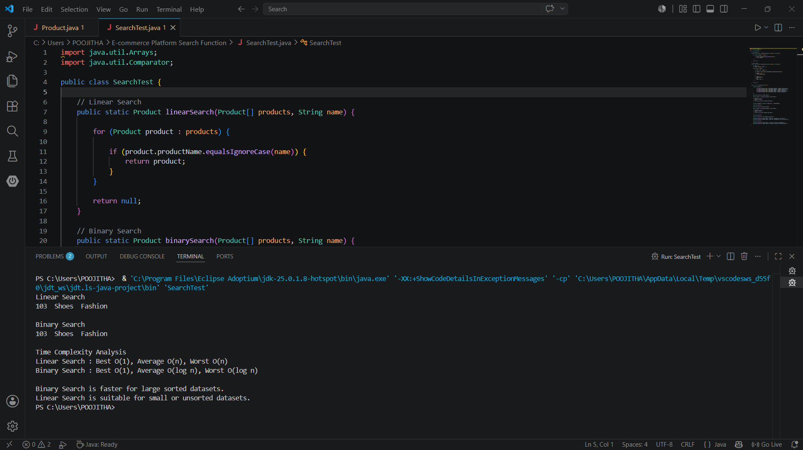
EX-3: FinancialForecast
FinancialForcast.java
public class FinancialForecast {

public double predictFutureValue(double currentValue, double growthRate, int years) {

if (years == 0) {
return currentValue;
}

return predictFutureValue(currentValue * (1 + growthRate), growthRate, years - 1);
}
}
Main.java
public class Main {

public static void main(String[] args) {

FinancialForecast forecast = new FinancialForecast();

double currentValue = 10000;
double growthRate = 0.10; //10%
int years = 5;

double futureValue = forecast.predictFutureValue(currentValue, growthRate, years);

System.out.println("Current Value : " + currentValue);
System.out.println("Growth Rate : " + (growthRate * 100) + "%");
System.out.println("Years : " + years);
System.out.printf("Future Value : %.2f", futureValue);

System.out.println("\n");
System.out.println("Time Complexity : O(n)");
System.out.println("Optimization : Dynamic Programming or Memoization can be used");
}
}
Output:
